CineConcert NOSFERATU

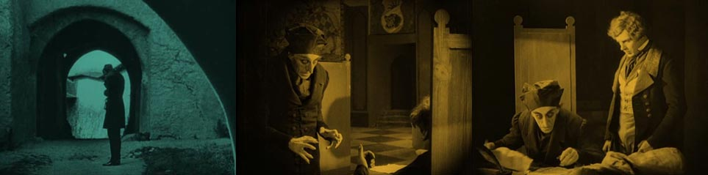
NOSFERATU – A Symphony of Horror
Silent film, Germany 1921
Digitally restored complete version 2006
With new piano soundtrack by Markus Horn
Running time: approx. 94 minutes
THE FILM

Shot in 1921 and released in 1922, Nosferatu was an unauthorized adaptation of Bram Stoker's Dracula, with names and other details changed because the studio could not obtain the rights to the novel (for instance, "vampire" became "Nosferatu" and "Count Dracula" became "Count Orlok"). Stoker's heirs sued over the adaptation, and a court ruling ordered that all copies of the film be destroyed. However, one print of Nosferatu survived, and the film came to be regarded as an influential masterpiece of cinema.

The etymological origins of the word "Nosferatu" are difficult to determine. Source for the term seems to be 19th-century British author and speaker Emily Gerard, who used it in her travelogue "The Land Beyond the Forest". She merely refers to it as the Romanian word for vampire.

THE STORY

In the town of Wisborg, estate agent Mr. Knock is pleased to receive a commission from Count Orlok to find a house for him. He dispatches his young assistant, Hutter, to Orlok's castle in the far off Carpathians. He tells Hutter to get him to buy the vacant house just opposite Hutter's own. Hutter arrives at his destination safely and the Count is all too eager to buy the proposed property especially after he sees a photo of Hutter's pretty young wife Ellen. Hutter soon realizes the evil he's dealing with and is locked away while Orlock makes his way by ship to Wisborg.
As Orloc travels to Wisbourg, plague descends in his wake and the people of Wisborg begin to sense the coming of evil. Hutter eventually escapes Orloc's castle determined to return home as quickly as possible but exhausted and ill, finds himself in hospital. Hutter nonetheless arrives home the same day as Orlok and the townsfolk begin to panic over the increasing number of deaths...
THE MUSIC

To see Markus Horn's new score live is to experience a whole lot more than merely a piano playing along to a film. Combining elements of classical music, jazz, pop and avant-garde and enhancing them with a large portion of improvisation, this soundtrack creates an entirely unique, fascinating universe. With jazzy grooves, pop harmonies and abstract passages Horn's musical language goes beyond the typical influences of late romanticism, bringing new impulses and fresh sounds to the world of silent film accompaniment.
In recent years Horn performed his music to Fritz Lang's masterpiece "Metropolis" at shows all over the world, receiving standing ovations for his intense symbiosis of film and music. With" Nosferatu" he is now presenting his second soundtrack to a German silent film. The score premiered in November 2015 at the 10th “Teaneck International Film Festival” in New Jersey, followed by concerts in New York City, Turkey and California (opening event of the 22th “San Luis Obispo International Film Festival” a.o.).
Preparations for a new project can take up to six months. Compositions, themes and motives are created to then develop further with the story line and serve as a basis for improvisation. In addition, gaining detailed knowledge of the film is absolutely vital, in order for the pianist to be entirely synchronised with the plot and to breathe with the film. The resulting live show is an independent, powerful and lyrical accompaniment to F.W. Murnau's expressionistic silent movie masterpiece.
BIOGRAPHY

 | Markus Horn (*1972) studied piano with a focus on jazz/pop in Amsterdam (NL) as well as at the Hannover University for Music and Drama. He received highest awards and prizes in several competitions. Concerts in most varied instrumentations took him all over Germany, to Switzerland, Italy, USA, Finland, Iceland, Denmark, Hungary, Bulgaria, Singapore, Malaysia, Vietnam, Indonesia and Chile. He performed on the radio for the Hessischer Rundfunk and Norddeutscher Rundfunk and on TV for ZDF, RTL, RTL II and Hessen Fernsehen. Furthermore, he contributed to numerous CD-productions

THE PLOT

In 1838, Thomas Hutter lives in the fictional German town of Wisborg.[3] His employer, estate agent Herr Knock, sends Hutter to Transylvania to visit a new client named Count Orlok who plans to buy a house in Wisborg. Hutter entrusts his wife Ellen to his good friend Harding and Harding's sister Annie before embarking on his journey. Nearing his destination in the Carpathian Mountains, Hutter stops at an inn for dinner. The locals become frightened by the mere mention of Orlok's name and discourage him from traveling to his castle at night, warning of a werewolf on the prowl.
The next morning, Hutter takes a coach to a high mountain pass, but the coachman declines to take him any further than the bridge as nightfall is approaching. Another coach appears after Hutter crosses the bridge and its coachman gestures for him to climb aboard. Hutter is welcomed at a castle by Count Orlok. When Hutter is eating dinner and accidentally cuts his thumb, Orlok tries to suck the blood out, but his repulsed guest pulls his hand away.
Hutter wakes up to a deserted castle the morning after and notices fresh punctures on his neck which, in a letter he sends by courier on horseback to be delivered to his wife, he attributes to mosquitoes. That night, Orlok signs the documents to purchase the house across from Hutter's own home in Wisborg and notices a photo of Hutter's wife, remarking that she has a "lovely neck."
Reading a book about vampires that he took from the local inn, Hutter starts to suspect that Orlok is a vampire. He cowers in his room as midnight approaches, with no way to bar the door. The door opens by itself and Orlok enters, and Hutter hides under the bed covers and falls unconscious. Meanwhile, his wife awakens from her sleep, and in a trance walks towards her balcony and onto the railing. Alarmed, Harding shouts Ellen's name and she faints while he asks for a doctor. After the doctor arrives, she shouts Hutter's name, apparently able to see Orlok in his castle threatening her unconscious husband.
The next day, Hutter explores the castle. In its crypt, he finds the coffin in which Orlok is resting dormant. Hutter becomes horrified and dashes back to his room. Hours later from the window, he sees Orlok piling up coffins on a coach and climbing into the last one before the coach departs. Hutter escapes the castle through the window, but is knocked unconscious by the fall and awakens in a hospital.
After recovering, Hutter hurries home. Meanwhile, the coffins are shipped down river on a raft. They are transferred to a schooner, but not before one is opened by the crew, revealing a multitude of rats. Sailors on the ship fall ill, and soon all but the captain and first mate are dead. The first mate goes below to destroy the coffins, but Orlok awakens and the horrified sailor jumps into the sea. When the ship arrives in Wisborg, Orlok leaves unobserved, carrying one of his coffins, and moves into the house he purchased. The next morning, when the ship is inspected, the captain is found dead. The doctors conclude that the plague is to blame. The town is stricken with panic, and people are warned to stay indoors.
There are many deaths in the town, which are blamed on the plague. Ellen reads the book Hutter found, which claims that a vampire can be defeated if a pure-hearted woman distracts the vampire with her beauty. She opens her window to invite Orlok in, but faints. Hutter revives her, and she sends him to fetch Professor Bulwer, a physician. After he leaves, Orlok enters and drinks her blood as the sun begins to rise. Knock, who has been committed after having murdered the warden of a psychiatric ward, senses the threat to Orlok, but cannot escape his cell to warn him. A rooster crows, and the sunlight causes Orlok to vanish in a puff of smoke. Ellen lives just long enough to be embraced by her grief-stricken husband. Count Orlok's ruined castle in the Carpathian Mountains is then shown.

BOOKING CONTACT

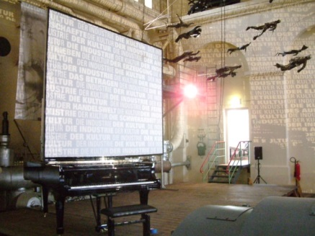 | Agentur artcontact  Wilhelm-Busch-Str. 15  D-60431 Frankfurt am Main  Phone.: ++49 69-52 63 00  Email: info@artcontact-ffm.de
PERSONAL CONTACT

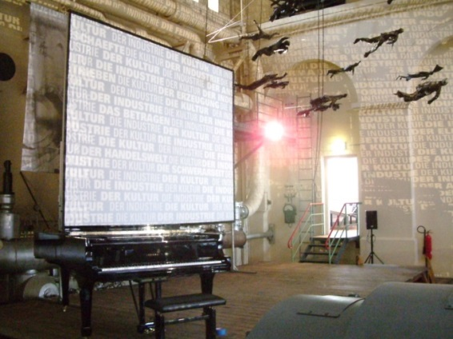 | Markus Horn  Droste-Hülshoff-Weg 60  D-30629 Hannover  Tel.: ++49 511-2831722  Fax: ++49 511-2281780  Mobil: ++49 173-6209591  Email: info@markushorn.de  Web: www.markushorn.de
www.nosferatu.markus-horn.net

